Ancestral Memories & Your Calling
January 25, 2018

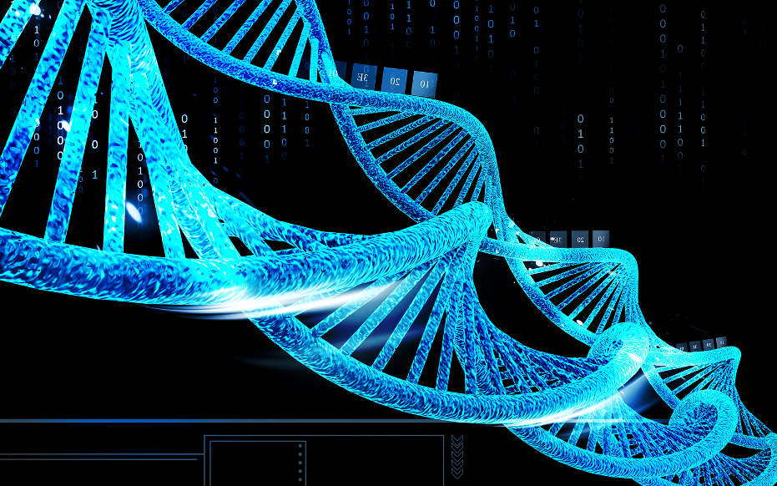
Oh, thank you, Jesus for encouraging us to reach higher and higher to accomplish your will in our lives.

My dear Heartdwellers, recently the Lord revealed to me that I have Jewish blood, and that many, through DNA testing, can discover something about their lineage. Of course, my curiosity was boiling over...

So, I read a few articles and then sent my samples to be analyzed. My ancestry is from Prague, the highest concentration of Jews in Europe. France. England, Northern Africa and the Middle East. That was quite a shock to me, that I have Jewish ancestry. But I realized many in these areas took to hiding in the Catholic Church, because of persecution.

And my mother looked very Jewish to me, although she staunchly denied it.

Jesus began, "My dear ones, there are many secrets in your ancestry. Your heart, and what makes up many of your desires, has its roots there. If you have a fire in your soul and gentleness in your heart that seeks to relieve the suffering of man, the chances are good that somewhere in your past is lineage related to My mother's family—and even further back to King David.

"This predisposition to goodness is a distinguishing mark of My presence in you now, but long before you were born again, if this existed in your hearts, it is another sign that somewhere in your DNA you are related to Mine.

“The problems come in when the contaminated side of your family takes precedence over the loving side. You may not see or understand any of this by just looking over your genealogy, but it is there, buried and indelibly printed in your heart. You want to live to do good. That should tell you much about your origins.

“In every soul, there is good and bad; it is up to them to decide which they want to give life to. And there are seasons that souls go through where they ‘experiment’ as it were, to see if a different path will bring them fulfillment.

“But the ones who trace back to My family will be solely preoccupied with doing good for one another. There are no tests as yet to prove who you are, but there will be. Nevertheless, it is I who call and empower; it is you who responds. The basic DNA is there, but also are the more negative DNA influences. It is up to you, My dear ones, to always choose the better part.

“You may have experienced genetic memory when you are drawn to the Middle East and Jerusalem and the Holy Land.”

Wow Lord! My heart ached very much tonight for Israel and the Jews who still will not hear of You. Oh, my heart breaks when I think of the many who will not even consider the prophecies that are SOLID proof of who You are. Especially when I hear of people looking for the Messiah in David’s blood line, thinking he is alive now and hiding. Oh, how treacherous that could prove to be.

Jesus replied, “Do not worry, My Love. I am fully able to prove to those who have eyes to see and ears to hear, although it will cause an uproar.”

But Lord, they already know through the prophet Yitzak Kaduri, who died at 108 and spent his last years in visionary experiences with You... right?

By the way, he wrote the Messiah's name using the encryption of the first letters of each word in a phrase.

Jesus answered, “Indeed, but what one knows with his intellect and what one is willing to believe in his heart are two separate issues. This stubbornness goes deep, very deep.”

Lord, did they find the arc and move it? Or try to remove all traces of a blood? (That's been something that's been on my heart for a while.)

“Clare, My salvation will not be hidden. It will come to the Light, My Beloved, it will.

"Dear ones, the ache in your heart for this is yet another sign to you of your predestination.

“I am sharing this with you, because I want you to live up to who you are, in Me. First and foremost, you are children of the Great King. And then you have roots that would shock you. You are not orphans. If your dreams and desires are not of this world but of the world to come—which I have called all who care to be a part of, to participate in—you are of the Family of God. I want you to understand that there are no mistakes when I call a soul. I know fully well who each and every one of you are and what you are capable of with My anointing. And it is so much more than what you are doing.

“There are so many aspects of your lives that are not worth your attention—and I am calling you to detach from those. Deny yourself, pick up your cross, and follow Me. You are very special to Me, very special. I have gone through great lengths to communicate that to you. Live up to that, My Children, My Brides, live up to that.

"You must feed that fire in worship, then direct it in ministry. Overwhelming love is waiting for expression from your heart. What you feel on the inside must be shared. Celebrate who I am to you. Celebrate the life I’ve given you in Me. Celebrate the beauty I created, celebrate My love and desire to heal the brokenhearted. Celebrate My death as proof of My love. Oh, there is so much to celebrate! Come forth and celebrate Who I Am to the world.

“I celebrate who you are to Me. I sing and chant over you; cry and laugh over you. I encourage you in your darkest hours and hold you up when you are failing. And I celebrate that you’ve given your whole life to Me.

“You are greatly feared and loved by many. My people, the world sees Me in you, they hear Me when you speak - and for many, many of you on this Channel, they are woven into your very DNA. Do not look down upon yourself. Look down on your sins and temptations, but not on your ‘self.’ Your self is even too beautiful for Me to express to you in words. You are so far above the things that have held you back, so far. You do not realize how far beneath you they are.

"So many of you know nothing about the watches of the night, when I take you to many places around the world to minister. I keep these things from you, because of your pride. But rest assured, I use you mightily in many, many ways.

“You are anointed to break through to people’s hearts, to open what has been closed because of woundedness. To open what is sealed in concrete, the brokenness of souls who have experienced life’s worst. You have an anointing to heal hearts, because I live in you.

“Yes, indeed, you are the very ones I chose, beginning with Abraham. Call to My hidden and lost children and they will hear My voice.

“All of this is miraculous. It is not ‘of this world’, rather it is timelessly ordained by My Father that it should be so. I will not allow you to be shut down anymore. Promise Me your all, and I will see to it that My all shines through you.

“Continue to say, 'Yes' My holy ones; continue to say, 'Yes'. Let Me pour through you all I have to give. Do not frustrate My plans for you by giving yourself to anything of lesser value.

“Do you see? What you are called to has value far beyond anything that is of this world. So, please do not waste your time on it. Do not waste My time on it. You have not recognized the greatness of your souls; therefore, you have not corresponded fearlessly. I have become desperate to prove to you your very special and unique worth to Me.

“Talk about frustration! Oh, it is far beyond what you can imagine. But now you are closer than ever in realizing who you are and what your destinies are. Yes, it extends beyond this life, yes. But now, in this life, there is so much for you to do for Me. So much. I am helping you to discover your specialness, so you will pour yourself out on others fearlessly, with great love.

“Oh, how I wish to tell you so much more. Why you relate so strongly to certain characters in Scripture. What is in your DNA that is in theirs and why you relate to them. When you read in the Scriptures, something deep inside stirs in you. There is a reason for that. Nothing is coincidence. Nothing. Everything is inter-connected and has a purpose.

“What is written in Scripture is also a calling card to My people to rally around Me in these last days. When their hearts are lit afire by a passage of Scripture, they can be sure there is a DNA memory there. The tests they have for DNA and the knowledge is still very primitive. There is SO much more present in a soul in their DNA than they can imagine. And by My grace, that can be released at any time and manifest in this life.

“Yes, My people, many of you who are drawn to this Channel are brought here by ancient memories in your DNA that correspond to what I share with her. Your fascination with Israel and the Holy Lands, all of that has substance in your DNA memories.

“Do you know that it is possible to create a movie from DNA? That’s right. All the sights, sounds, smells and sensory records are there in the DNA and someday you will see movies of your ancestor’s past. You will understand so much more of your life on Earth when you do.

“I wish for you to be less and less dependent on exterior things, but I understand that so much is written in your DNA that you are attracted to. When I stimulate or release a certain DNA memory in you, so much more comes to the surface, as has happened to you, Clare, when you did the Exodus recordings.”

Since the Lord was speaking about this, I decided to Google "DNA memory". And this is what I found:

They recently discovered at Harvard University that 1 gram of DNA can store 700 Terabytes of data. That's 700,000 megabytes of data in one gram of DNA. Zechariah’s Patrol recently published an article titled “Genetic Memory Part I” written by Drs. Alex and Georgina Perdomo.

They state that: "After so many generations of the 10 northern tribes of Israel, scattered throughout the world, and without remembering who they are… One generation may come, where these memories stored in the genes of the cells of the brain that had been off for many generations, may be turned on."

Oh, I totally believe that. I feel like it's happened to me, when I discovered things about the arc and... the Big Ark and the arc of the covenant.

Then they site these three things:
1) They hear the Word of God and become Biblical Christians.

2) They REMEMBER who they are, or

3) They return to Haaretz, The Land.

"The trigger that the Lord uses to turn on that genetic memory is usually the Word of God (the voice of Yeshua); but other times the trigger for that ancient memory may be the Torah, the land of Israel, the love for the Jews, the Hebrew language, the shofar, the music, the dances, the Feasts of the Lord or even Shabbat."

In this article, they explained that

"Monarch butterflies have something scientists call 'Genetic Memory' – which memory leads later generations to follow a path that could not have been physically known to them. Their point of comparison is that, after many generations of Ephraim’s ten northern tribes being scattered throughout the world, something similar might be happening to their heirs." They point out "that a generation is coming, even now is, in which “stored memories” are being awakened. Such memories are stored in the genes of the cells of the brain and can be “asleep” for generations, and then suddenly be turned on. Such is the case with the Monarch butterfly, and the same may well be true of Believers…"

Oh, I thoroughly believe that. And that's the end of the article.

And Jesus began again, “All of what you have just read is still primitive and only scratching the surface. It is possible for Me to show you a movie sourced only on the contents of your DNA, everything necessary to put the scene together is right there inside of you.

"My People, look up to who you are. Recognize your affinity for holy things. Recognize your desire to heal and love people. Recognize that I live in you when you invited Me into your heart with ALL of those desires. But your very DNA may well be connected to Mine in a physical way.

"And let this be an inspiration for you, to rise up and live your holiest in this life. Make it count for Me."

Amen to that!

God bless you, Heartdwellers. I just wanted to let you know that we are now Tax Exempt. So, we'll be compiling receipts for anyone who asks.

But I don't want to leave on that note. I wanted to mention to you that, on our website we have a new page giving some information about ministries for trafficked children that the Lord has moved on our hearts to donate to.

So, that would be under Outreach—the Outreach tab on our website.

God bless you all. And thank you for being part of this beautiful Family the Lord has called together. Oh, the wonders He has stored up for us! He is truly, truly amazing!

